Software Requirement Specifications

AI-Assisted Software Development Efficiency Analyzer



Submitted by
Muhammad Anas (S23BINFT1M01019)

Submitted to
Mr. Zaman Ali

Department of Information Technology
Faculty of Computing
The Islamia University of Bahawalpur

Meeting Details
Sr No | Details | Date | Supervisor Signature

Summary
This document presents the Software Requirements Specification (SRS) for the AI-Assisted Software Development Efficiency Analyzer. In short, the system watches how developers use AI tools while they are making software and rates how this affects their overall efficiency, such as how quickly they code, how good their output is, and how productive they are. The system collects detailed data on how developers and AI coding assistants interact with each other. This data is then used to create useful insights and performance metrics that encourage developers to use AI in their work in a more responsible and effective way.
The frontend of the system is built with React, the backend API is built with Laravel, the relational database is built with MySQL, and the integrated AI assistant is built with the OpenAI API. This document outlines all the functional and non-functional requirements, use case specifications, activity diagrams, and the technology architecture that together make up the full scope of the proposed system.
Table of Contents
1. Introduction 5
1.1. Purpose 5
1.2. Scope 5
1.3. Product Perspective 6
1.4. User Characteristics 6
1.5. Similar Apps and Systems / Literature Review 6
1.6. Proposed Technologies 7
2. Requirements 9
2.1. Functional Requirements 9
2.2. Non-Functional Requirements 14
3. Use Cases and Flow of Processes 15
3.1. Use Case 1 — Developer Registration and Login 16
3.2. Use Case 2 — Assign Coding Task 19
3.3. Use Case 3 — Conduct AI-Assisted Coding Session 21
3.4. Use Case 4 — Analyse Session and Compute Performance Metrics 24
3.5. Use Case 5 — View Performance Metrics Dashboard 26
3.6. Use Case 6 — Receive Insights and Recommendations 28
3.7. Use Case 7 — Receive Adaptive AI Assistance 30
3.8. Use Case 8 — Track Skill Development 32
3.9. Use Case 9 — Manage System Administration Panel 34
4. References 36

1. Introduction

AI-powered coding tools like GitHub Copilot and ChatGPT are now a normal part of making software. These tools help developers write code, fix bugs, and speed up everyday tasks. These tools clearly make people more productive, but an important question still needs to be answered: are developers really using them in a good way, and how do these tools affect their actual performance?
The AI-Assisted Software Development Efficiency Analyser is meant to look into this issue. It is an online system that keeps track of how developers use AI tools while they are coding. The system then looks at how these interactions change the speed, quality, and productivity of coding.
The platform is mostly for students, developers, and researchers who want to learn more about how AI is used in software development today. It is especially helpful in schools and universities where the use of AI tools is growing quickly and needs to be looked at carefully.

Purpose
The main goal of this document is to clearly explain what the AI-Assisted Software Development Efficiency Analyzer needs and how it works.
- To make a system that checks how developers use AI tools to make software.
- To find out how AI tools affect the quality of code, the productivity of developers, and their performance.
- To get useful information and performance metrics that encourage responsible use of AI
- To list all of the system's functional requirements, or the specific things it must be able to do.
- To list all the non-functional requirements, which are the quality limits that the system must meet.
- To give detailed use case specifications and activity diagrams for each major process.
This document tells you what the system should do and how it should work in different situations. It also defines both functional and non-functional requirements, along with use cases and system workflows.
This SRS is a simple guide for developers, managers, and testers to understand how the system works and what it is supposed to do.

1.2. Scope

The proposed system is a web-based application that gives you everything you need to fully analyse how well developers do when they use AI tools.

It has a coding workspace in a web browser where developers can write and test their code while talking to an AI assistant. The system keeps track of different things that happen during each session, like code changes, AI prompts, execution results, and errors.

The system uses this data to make performance metrics after the task is done. These numbers show how well the developer did their job and how much they relied on AI.

The system also has a dashboard where users can see how their performance has changed over time, how they use AI, and how far they've come overall.

But this version doesn't have some features on purpose. For instance, integration with platforms like GitHub, support for mobile devices, and cloud deployment are outside the current scope.

1.3. Product Perspective

The AI-Assisted Software Development Efficiency Analyser is a web-based system that works on its own. There are four parts to it: a React-based frontend that gives you a coding workspace and dashboard, a Laravel-based backend REST API that handles business logic and authentication, a MySQL database that stores all user accounts, session logs, and calculated metrics, and the OpenAI API integration that makes the AI assistant panel work. The system is set up so that the AI provider can't change the core measurement and insight engine. This means that future versions could add other AI services without having to make big changes to the analytics part.

1.4. User Characteristics
The following users interact with the AI-Assisted Software Development Efficiency Analyzer:

User Role | Technical Level | Primary Interaction with the System
Developer | Intermediate to Advanced | Uses the coding workspace, talks to the AI assistant, and looks at personal performance metrics and suggestions.
Team Lead / Supervisor | Advanced | Monitors team productivity reports, looks at how developers use AI, and looks at trends in the overall quality of the code.
System Administrator | Advanced (IT Background) | Manages user accounts, sets up system settings, creates and assigns coding tasks, and keeps an eye on the health of the platform..

All users access the system through a standard modern web browser. No local software installation is required beyond a stable internet connection.

1.5. Similar Apps and Systems / Literature Review
The table below looks at tools and research that are already available and relevant to this project. It shows what they can do and what the AI-Assisted Software Development Efficiency Analyser is meant to fill.
System / Study | Key Feature | Shortcoming Addressed by This Project
GitHub Copilot | AI code suggestion integrated into editors | It gives AI suggestions, but it doesn't check to see if they help or hurt the quality of the code or the performance of the developers.
WakaTime | Tracks time spent coding per language and project | It keeps track of coding time but doesn't look at how AI affects productivity, interaction, or code quality.
CodeClimate | Automated code quality analysis after commit | Checks the quality of the code after it has been submitted; does not keep an eye on how developers and AI interact or how productive they are in real time.
LeetCode / HackerRank | Programming challenges with automated grading | Checks how good someone is at solving problems, but doesn't keep track of how they use AI or how it affects them.
Vaithilingam et al. (2022) | Academic study of GitHub Copilot usability | Finds problems with usability but doesn't make a tool that can be used to keep an eye on developers all the time.
Ziegler et al. (2022) | Measuring GitHub Copilot productivity impact | Looks at acceptance rates but doesn't look at how code quality gets worse or how AI dependence grows over time.

1.6. Proposed Technologies
The following technologies will be used to develop the AI-Assisted Software Development Efficiency Analyzer:

Layer | Technology | Role in the System
Frontend | React.js , Tailwind CSS , Monaco Editor , Chart.js | Makes the interactive coding workspace, dashboard, and all the UI parts.  Gives all interface elements responsive, utility-first styling.  It runs the code editor in the browser, which is the same engine used by Visual Studio Code.  Makes graphs of code quality, AI use, and performance trends.
Backend | Laravel (PHP) , Laravel Sanctum | Manages all REST API endpoints, authentication, sessions, and business logic.  Offers token-based API authentication to keep communication between the front end and back end safe
AI Integration | OpenAI API (GPT-4o) | It powers the AI assistant panel, which gives code suggestions, helps with debugging, and makes documentation.
Database | MySQL | Keeps all user accounts, coding tasks, session event logs, and calculated performance metrics..
Data Exchange | RESTful JSON API | Links the React front end and the Laravel back end in a clean, separate way.

Requirements

The main goal of the AI-Assisted Software Development Efficiency Analyser is to look at how developers use AI tools while they are making software and to see how those tools affect performance, productivity, and code quality. A structured workflow makes this mission possible. A programmer logs into the system and gets a programming job. The developer can use the AI assistant panel freely while working on the task in the integrated coding workspace. The session log keeps track of everything that happens in real time, including every AI prompt, code change, error, and execution event. When the developer sends in the solution, the analytics engine looks at the log, calculates a full set of performance and quality metrics, and displays them through the dashboard alongside personalized insights. The functional requirements below spell out each separate feature that the system needs to have in order to support this workflow.
In real life, developers might use AI tools in different ways depending on how much experience they have. Because of this, the system is more interested in finding usage patterns than in judging performance strictly.

2.1. Functional Requirements

2.1.1. FR001 – Developer Authentication
- Name:
FR001
Purpose: This feature allows users to register and log in to the system so they can access their personal workspace and analytics.
- Users: Developer, Team Lead, System Administrator
- Input:
- Name: Full name of the user
- Email Address: Valid email used for login
- Password: Minimum 8 characters with at least one number and one special character
- Role: Developer, Team Lead, or Administrator
- Display Picture: Optional
- Output: After successful registration, the user account is created and the system redirects the user to their respective dashboard. A new analytics profile is also initialized for developers.

2.1.2. FR002 – Coding Task Assignment
- Name:
FR002
- Purpose:
Allow the System Administrator to create programming tasks and assign them to specific developers so that each session is anchored to a clearly defined challenge.
- User(s):
System Administrator (creates task); Developer (receives task)
- Input:
  - Task Title: Short, descriptive name for the programming challenge.
  - Task Description: Complete problem statement, input/output specifications, and acceptance criteria.
  - Difficulty Level: Selected from: Beginner, Intermediate, or Advanced.
  - Time Limit: Maximum allowed duration in minutes, enforced by the system timer.
  - Programming Language: The language in which the solution must be written (e.g., Python, JavaScript, PHP).
  - Assigned Developer(s): One or more developer accounts selected from the user list.
- Output:
The task appears in the assigned developer's workspace queue and a notification is sent to each assigned developer. The session timer is initialized.

2.1.3. FR003 – AI-Assisted Coding Workspace
- Name:
FR003
- Purpose:
Provide an integrated, browser-based coding environment where developers can write and execute code while interacting with the OpenAI-powered AI assistant, with all interactions logged automatically.
- User(s):
Developer
- Input:
  - Code Input: Developer writes or edits code in the Monaco editor with syntax highlighting.
  - AI Prompt: A natural-language question or request submitted to the AI assistant panel.
  - Run Command: Triggers code execution and displays output or runtime errors below the editor.
  - Language Selection: Sets the programming language for syntax highlighting and execution context.
- Output:
The system displays AI responses in the assistant panel, shows execution output in the terminal panel, and records every edit, prompt, execution, and error event to the session log in real time.

2.1.4. FR004 – Real-Time Interaction Tracking and Session Logging
- Name:
FR004
- Purpose:
Continuously capture and persist all developer-AI interaction events throughout the coding session to build a complete, timestamped audit trail for the analytics engine.
- User(s):
System (fully automated)
- Input:
  - Session Start Timestamp: Recorded automatically when the developer opens a task.
  - AI Prompt Text and Timestamp: The exact text and submission time of every AI query.
  - AI Response Timestamp: The time at which the OpenAI API returns each response.
  - Code Edit Events: Every insertion, deletion, and paste operation in the editor.
  - Code Execution Events: Each time the developer clicks Run, including the result (pass or fail).
  - Runtime Error Events: Full error messages and timestamps for every execution failure.
  - Session End Timestamp: Recorded when the developer clicks Submit Solution or the timer expires.
- Output:
All events are stored in the MySQL database, linked to the session ID and task ID, and immediately available to the analytics engine upon task submission.

2.1.5. FR005 – Performance, Productivity, and Code Quality Analysis
- Name:
FR005
- Purpose:
This feature processes the captured session log to compute a set of metrics that reflect developer efficiency, including performance, productivity, and code quality.
- User(s):
System (automated, triggered on task submission)
- Input:
  - Session Log: All timestamped interaction events from the completed session.
  - Submitted Code: The final solution submitted by the developer.
  - Task Metadata: Difficulty level, time limit, and programming language.
- Output:
The engine produces and stores: (1) Performance Score based on task completion speed; (2) Productivity Score based on code correctness and execution pass rate; (3) Code Quality Score based on syntax errors, complexity, and readability; (4) AI Dependency Level classified as Low (0-3 prompts), Medium (4-8), or High (9+); (5) Overall Efficiency Score (0-100) as a weighted composite of all dimensions.

2.1.6. FR006 – Performance Metrics Dashboard
- Name:
FR006
- Purpose:
Display an interactive, data-rich dashboard that visualizes the impact of AI tool usage on the developer's overall development efficiency over time.
- User(s):
Developer, Team Lead
- Input:
  - Date Range Filter: Selects the time window for which analytics are displayed.
  - Metric Selector: Lets the user focus on specific metrics such as AI usage, code quality, or speed.
  - Developer Selector (Team Lead only): Allows a Team Lead to view any individual developer's metrics.
  - Export Request: Generates a downloadable PDF or CSV report of the selected data.
- Output:
The dashboard renders: Efficiency Score trend line chart; AI Dependency bar chart per session; Performance vs Productivity scatter plot; Code Quality trend line; and a summary card showing the most recent Efficiency Score and percentage change from the previous session.

2.1.7. FR007 – Insight and Recommendation Engine
- Name:
FR007
- Purpose:
Generate personalized, data-driven insights and recommendations after each session to guide developers toward more efficient, optimized, and responsible use of AI in their development workflow.
- User(s):
Developer
- Input:
  - Current Session Metrics: Efficiency Score, AI Dependency Level, Code Quality Score, and Performance Score from the completed session.
  - Historical Averages: The developer's rolling average metrics from all previous sessions.
  - Benchmark Thresholds: System-defined optimal ranges for each metric by task difficulty.
- Output:
The system displays 3 to 5 prioritized, plain-language insights on the post-session screen. For example: 'You submitted 11 AI prompts for a Beginner task — try fewer than 4 next time.' or 'Your Code Quality Score improved by 22% compared to last week.'

2.1.8. FR008 – Adaptive AI Assistance
- Name:
FR008
- Purpose:
Automatically calibrate the depth and detail of OpenAI API responses based on the developer's inferred skill level, encouraging growth rather than dependency.
- User(s):
System (automated); Developer (indirect)
- Input:
  - Skill Level Profile: Derived from historical session data: Beginner, Intermediate, or Expert.
  - AI Prompt: The natural-language query submitted by the developer.
  - Task Difficulty: The difficulty level of the active task.
- Output:
Beginner developers receive detailed, step-by-step explanations. Intermediate developers receive partial hints. Expert developers receive minimal one-sentence directional prompts. The calibration is achieved by prepending a skill-level instruction to every OpenAI API call.

2.1.9. FR009 – Skill Development Tracker
- Name:
FR009
- Purpose:
Track measurable improvement in developer skills over time by computing longitudinal trends across all completed sessions, making growth in developer performance metrics visible.
- User(s):
Developer, Team Lead
- Input:
  - All Completed Sessions: Every session associated with the developer's account.
  - Metric History: Historical records of efficiency scores, AI dependency levels, error rates, and code quality scores.
- Output:
The dashboard displays a Skill Growth panel showing: coding speed improvement (percentage reduction in average completion time), error reduction trend, AI dependency reduction trend, and an overall Skill Growth Index.

2.1.10. FR010 – System Administration Panel
- Name:
FR010
- Purpose:
Provide the System Administrator with a dedicated management panel for user account administration, task management, and system health monitoring.
- User(s):
System Administrator
- Input:
  - User Management Action: Create, edit, deactivate, or delete user accounts.
  - Task Management Action: Create, edit, assign, or archive coding tasks.
  - System Report Request: Generate a summary report of platform activity and usage statistics.
- Output:
The administration panel displays a user list with role and status filters, a task list with assignment status, and a platform activity summary including total sessions completed, average efficiency score, and most-used AI prompt categories.

2.2. Non-Functional Requirements
Non-functional requirements describe the quality attributes and constraints that the AI-Assisted Software Development Efficiency Analyzer must satisfy. These requirements govern how the system performs its functions, not what functions it performs.
ID | Quality Attribute | Requirement Description
NFR001 | Performance | Analytics results must be computed and displayed within 5 seconds of task submission on standard hardware.
NFR002 | Usability | A developer unfamiliar with the system must be able to complete a full coding session and view their dashboard within 10 minutes of first login, without external guidance.
NFR003 | Accuracy | The Efficiency Score must not differ by more than 5 points across two identical sessions with the same interaction log, ensuring measurement consistency.
NFR004 | Reliability | The system must support at least 50 concurrent developer sessions without data loss or response-time degradation.
NFR005 | Security | All passwords must be hashed using bcrypt. All API communication must use HTTPS. Session logs must be accessible only to the owning developer, their Team Lead, and the Administrator.
NFR006 | Portability | The application must function correctly on the latest versions of Google Chrome, Mozilla Firefox, Microsoft Edge, and Safari.
NFR007 | Maintainability | The codebase must follow the MVC pattern enforced by Laravel, with the frontend (React), API (Laravel), and database (MySQL) layers independently updatable without cascading changes.
NFR008 | Scalability | The MySQL schema must support the addition of new metric types and task categories through migration without altering existing session records.

3. Use Cases and Flow of Processes

Use cases are the formal representation of process flow defined by functional requirements. The three human actors are the Developer, the Team Lead, and the System Administrator. The system itself acts as an automated actor whenever background processes such as logging, analysis, or insight generation are triggered without direct user input.

The table below maps all actors to the use cases they participate in, showing the relationship between each use case and the functional requirement it implements.

Use Case | Name | Actor(s) | Requirement(s)
UC001 | Developer Registration and Login | Developer, Team Lead, System Administrator | FR001
UC002 | Assign Coding Task | System Administrator | FR002
UC003 | Conduct AI-Assisted Coding Session | Developer | FR003, FR004
UC004 | Analyse Session and Compute Metrics | System | FR005
UC005 | View Performance Metrics Dashboard | Developer, Team Lead | FR006
UC006 | Receive Insights and Recommendations | Developer | FR007
UC007 | Receive Adaptive AI Assistance | Developer, System | FR008
UC008 | Track Skill Development | Developer, Team Lead | FR009
UC009 | Manage System Administration Panel | System Administrator | FR010

Figure 1: System Level Use Case Diagram

3.1. Use Case 1 — Developer Registration and Login

ID | UC001
Name | Developer Registration and Login
Description | This use case describes the process flow of developer registration and login. A new user registers an account and subsequently logs in to access their role-appropriate workspace or dashboard.
Requirement(s) | FR001
Actor(s) | Developer, Team Lead, System Administrator
Precondition | The user has access to the application URL in a supported web browser and does not yet have an account (for registration) or has an existing account (for login).
Postcondition | The user is authenticated and redirected to the appropriate interface. An empty analytics profile is initialized for new Developer accounts.
Basic Flow | Basic Flow  1. User navigates to the application and selects Register.  2. User enters full name, email address, password, and selects a role.  3. System validates inputs against defined rules.  4. System creates the account and sends an email confirmation link.  5. User clicks the confirmation link and is redirected to the login page.  6. User enters email and password and clicks Login.  7. System authenticates credentials and redirects user to the appropriate interface.  Alternative Flow  1. Returning user opens the login page directly, enters credentials, and is authenticated.  Exceptions  1. Email already registered — System displays: An account with this email already exists.  2. Password does not meet complexity requirements — System highlights the field with inline guidance.  3. Incorrect login credentials — System displays: Incorrect email or password.

Diagrams
The activity diagram below describes the flow of events for Developer Registration and Login (UC001).

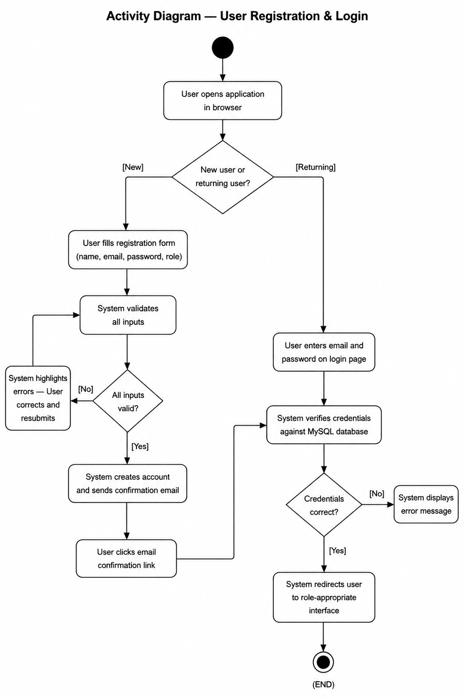

3.2. Use Case 2 — Assign Coding Task

ID | UC002
Name | Assign Coding Task
Description | This use case describes the process by which a System Administrator creates a programming task and assigns it to one or more developer accounts so the system can measure their performance during the session.
Requirement(s) | FR002
Actor(s) | System Administrator
Precondition | The Administrator is logged in with System Administrator privileges. At least one active Developer account exists.
Postcondition | The task is saved to the database and appears in the assigned developer's workspace queue. A notification is sent to each assigned developer.
Basic Flow | Basic Flow  1. Administrator opens the Task Management panel.  2. Administrator clicks Create New Task.  3. Administrator enters task title, description, difficulty level, time limit, and programming language.  4. Administrator selects one or more developers from the assignment list.  5. Administrator clicks Save and Assign.  6. System validates all required fields.  7. System stores the task in MySQL and sends an in-app notification to each assigned developer.  Alternative Flow  1. Administrator duplicates an existing task, modifies selected fields, and assigns it to a different developer group.  Exceptions  1. A required field is left empty — System prevents saving and highlights the missing field.  2. A selected developer account has been deactivated — System warns the Administrator.

Diagrams
The activity diagram below describes the flow of events for Assign Coding Task (UC002).

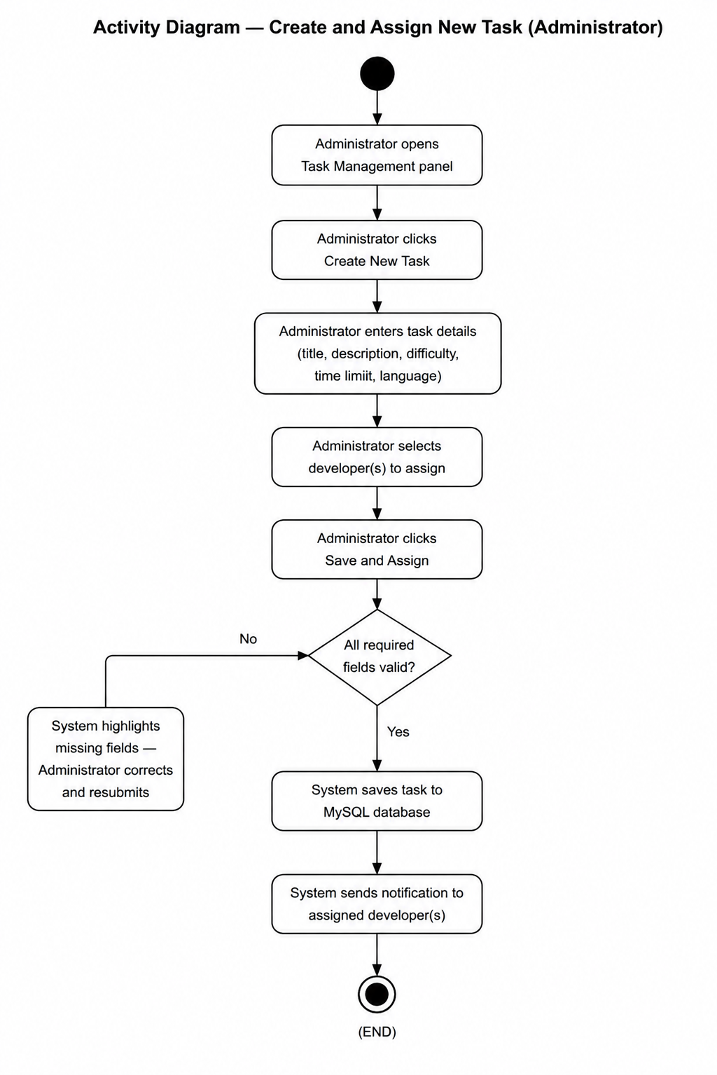

3.3. Use Case 3 — Conduct AI-Assisted Coding Session

ID | UC003
Name | Conduct AI-Assisted Coding Session
Description | This use case describes the complete sequence of events from the moment a developer opens an assigned task to the moment they submit their solution. This is the core interaction the system is built to measure.
Requirement(s) | FR003, FR004
Actor(s) | Developer
Precondition | The developer is logged in. At least one task is available in the workspace queue.
Postcondition | The developer's code is submitted. All interaction events are persisted to the session log in MySQL and forwarded to the analytics engine.
Basic Flow | Basic Flow  1. Developer selects an assigned task from the workspace queue.  2. System loads the task description, starts the session timer, and initializes the session log.  3. Developer reads the task brief and begins writing code in the Monaco editor.  4. System records each code edit event with timestamp.  5. Developer clicks Run Code.  6. System logs the execution event and any error messages.  7. Developer types a question in the AI assistant panel.  8. System sends the prompt to the OpenAI API and displays the response in the assistant panel.  9. System logs prompt text, prompt timestamp, and response timestamp.  10. Developer continues editing, guided by the AI response.  11. Developer clicks Submit Solution when satisfied.  12. System records submission timestamp and triggers the analytics engine (UC004).  Alternative Flow  1. Developer never uses the AI assistant — session logs zero AI prompts. The analytics engine classifies this as a Low Dependency session.

Diagrams
The activity diagram below describes the flow of events for conducting an AI-Assisted Coding Session (UC003).

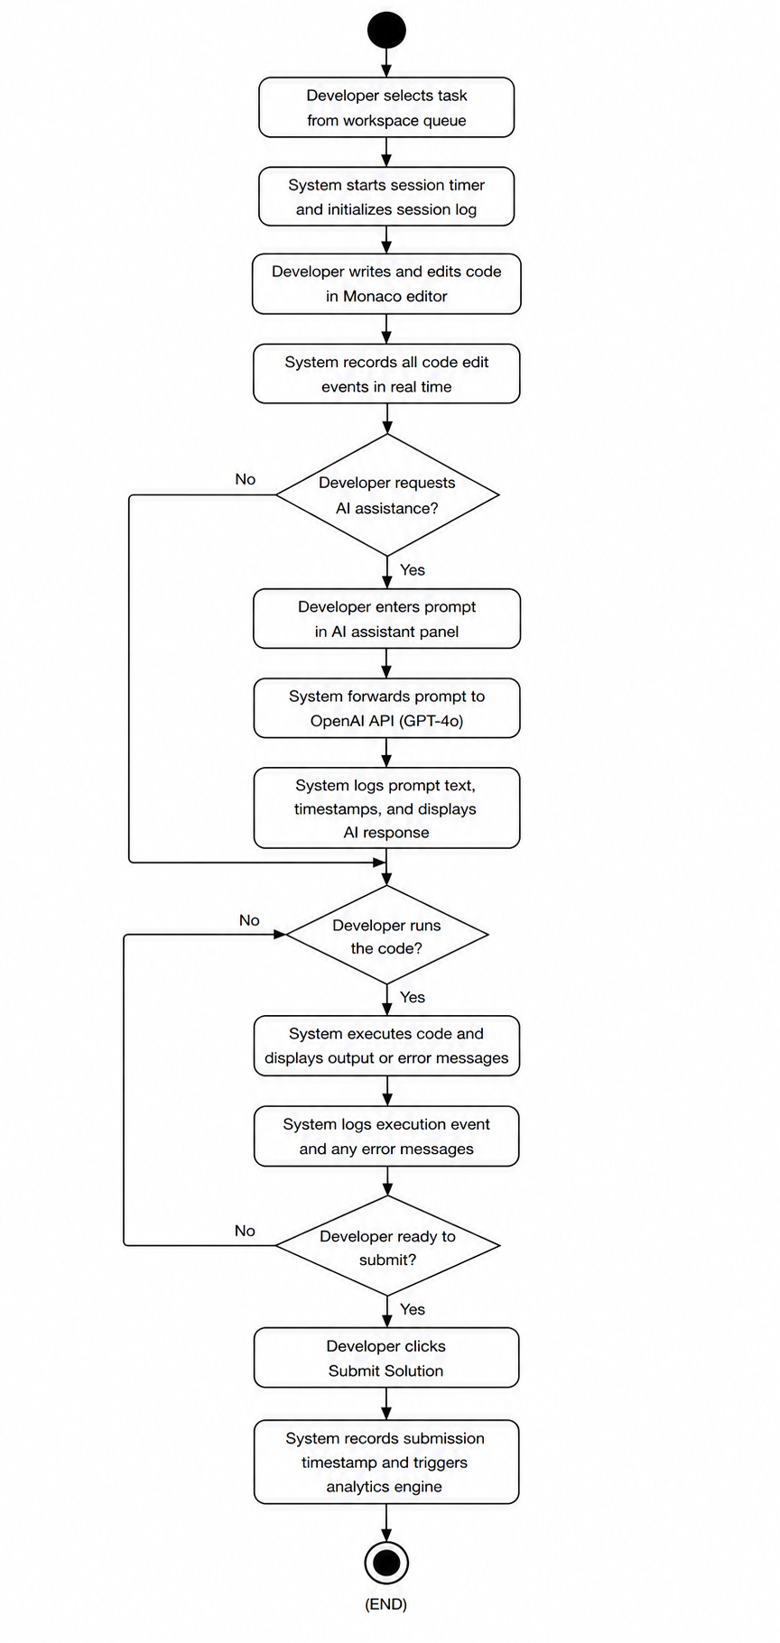

3.4. Use Case 4 — Analyse Session and Compute Performance Metrics

ID | UC004
Name | Analyse Session and Compute Performance Metrics
Description | This use case describes the automated process by which the analytics engine processes the session log to measure the impact of AI tool usage on developer coding effectiveness.
Requirement(s) | FR005
Actor(s) | System (automated)
Precondition | UC003 has completed. The full session log and submitted code are available in the MySQL database.
Postcondition | Performance Score, Productivity Score, Code Quality Score, AI Dependency Level, and Overall Efficiency Score are computed and stored. The dashboard and recommendation engine are triggered.
Basic Flow | Basic Flow  1. Analytics engine retrieves the session log and submitted code from MySQL.  2. Engine computes Performance Score: task completion speed relative to the assigned time limit.  3. Engine computes Productivity Score: code correctness, test pass rate, and meaningful lines of code.  4. Engine passes submitted code to the Code Quality Analyser: checks syntax errors, cyclomatic complexity, and readability.  5. Engine counts total AI prompts and classifies AI Dependency Level: Low (0-3), Medium (4-8), High (9+).  6. Engine applies weighted formula: Efficiency Score = Performance(30%) + Productivity(30%) + Code Quality(20%) + AI Usage Balance(20%).  7. Engine stores all computed metrics against the session record in MySQL.  8. System triggers dashboard update (UC005) and recommendation generation (UC006).  Exceptions  1. Session log is incomplete — Engine flags session as partial and computes available metrics only.

Diagrams
The activity diagram below describes the flow of events for session analysis and metric computation (UC004).
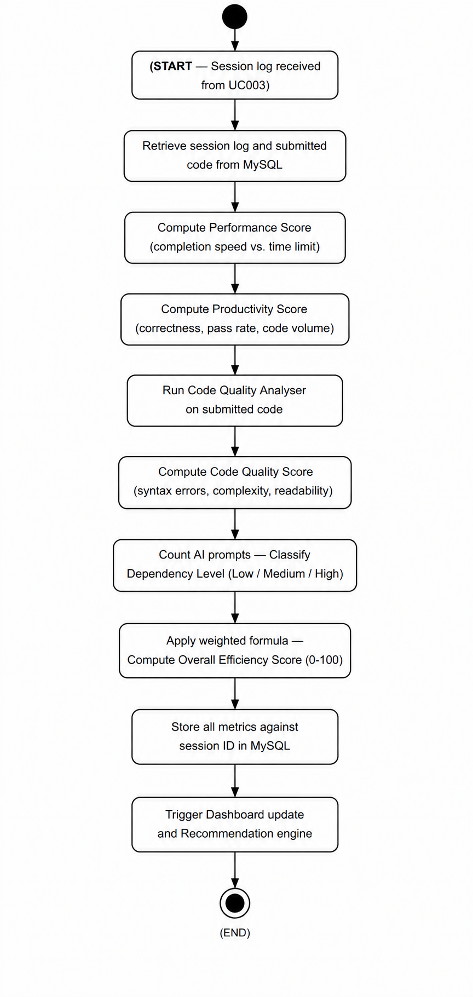

3.5. Use Case 5 — View Performance Metrics Dashboard

ID | UC005
Name | View Performance Metrics Dashboard
Description | This use case describes how a Developer or Team Lead accesses the analytics dashboard to review performance, productivity, code quality, and AI usage trends across all completed sessions.
Requirement(s) | FR006
Actor(s) | Developer, Team Lead
Precondition | The user is logged in. At least one completed and analysed session exists for the account being viewed.
Postcondition | The user views an interactive dashboard reflecting all analysed sessions within the selected date range.
Basic Flow | Basic Flow  1. User clicks Dashboard in the navigation menu.  2. System retrieves session metrics from MySQL and renders the default view (last 30 days).  3. User views the Efficiency Score trend chart, AI Dependency bar chart, and Code Quality trend line.  4. User applies a date range filter. System re-renders all charts for the selected period.  5. User clicks Export Report. System generates a downloadable PDF summary.  Alternative Flow  1. Team Lead selects a specific Developer from the dropdown to view that developer's individual metrics.  Exceptions  1. No sessions exist for the selected date range — System displays: No data available for the selected period.

Diagrams
The activity diagram below describes the flow of events for viewing the Performance Metrics Dashboard (UC005).

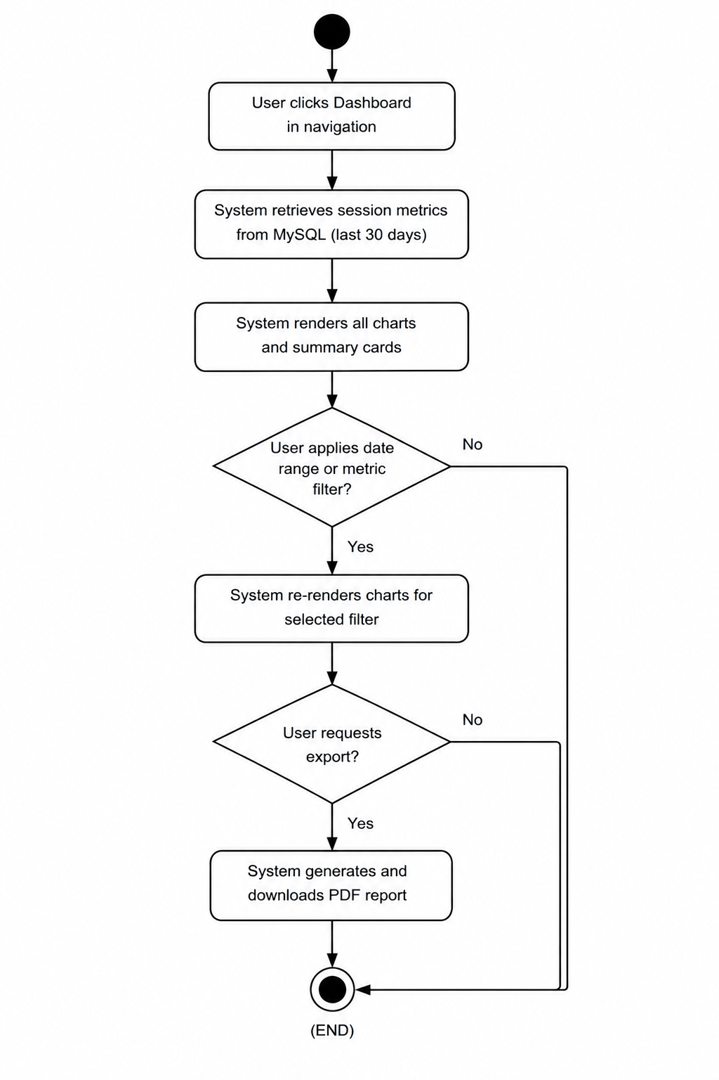

3.6. Use Case 6 — Receive Insights and Recommendations

ID | UC006
Name | Receive Insights and Recommendations
Description | This use case describes the automated generation and delivery of personalized insights to the developer after each session to promote efficient, optimized, and responsible AI usage.
Requirement(s) | FR007
Actor(s) | Developer
Precondition | UC004 has completed. Performance, productivity, code quality, and AI dependency metrics are stored for the most recently completed session.
Postcondition | The developer sees 3 to 5 prioritized, plain-language insights and recommendations on the post-session results screen.
Basic Flow | Basic Flow  1. Recommendation engine retrieves current session metrics and historical averages from MySQL.  2. Engine compares each metric against the developer's average and system-defined benchmarks.  3. Engine identifies the top 3 to 5 most impactful areas for improvement or recognition.  4. Engine generates plain-language insight statements for each area.  5. System renders insights on the post-session results screen, ordered by priority.  6. Developer reads insights and may click View Full Dashboard to explore further.  Alternative Flow  1. Fewer than 3 completed sessions — Engine displays generic onboarding guidance.  Exceptions  1. Metrics unavailable for the completed session — System displays: Insight generation is currently unavailable.

Diagrams
The activity diagram below describes the flow of events for generating insights and recommendations (UC006).
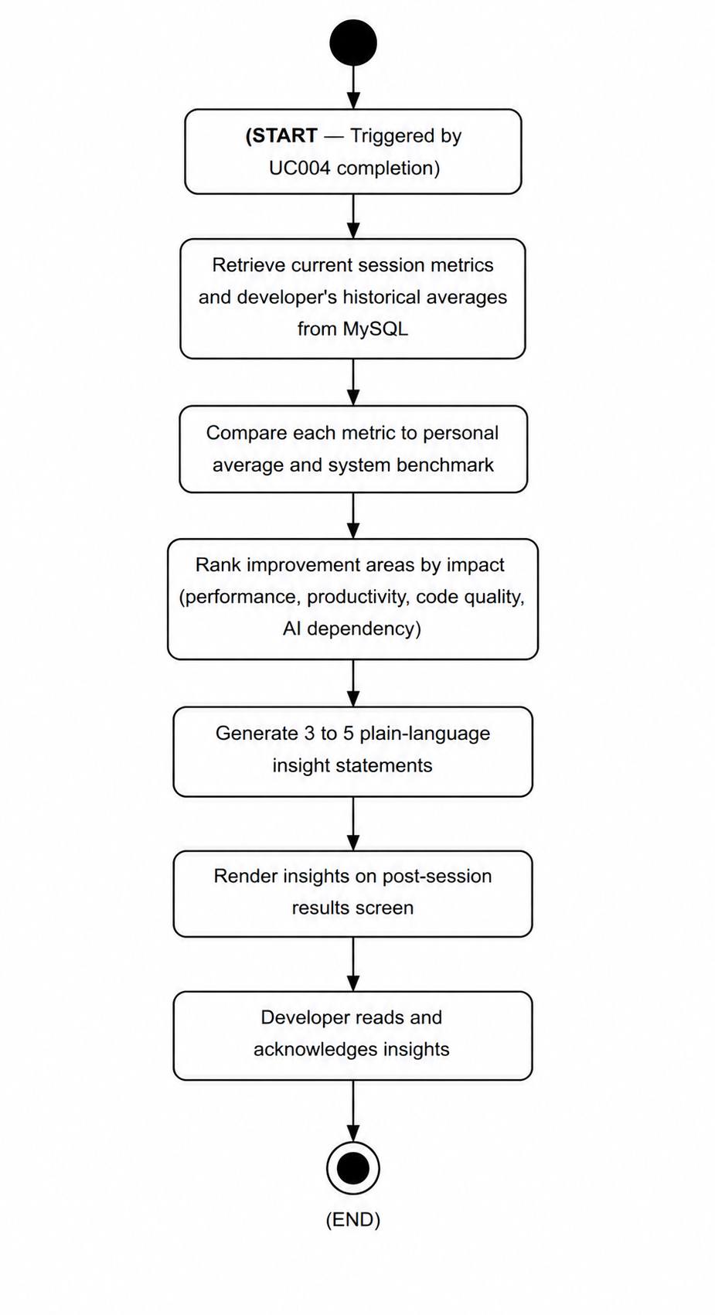

3.7. Use Case 7 — Receive Adaptive AI Assistance

ID | UC007
Name | Receive Adaptive AI Assistance
Description | This use case describes how the system automatically calibrates the depth of OpenAI API responses based on the developer's inferred skill level so that AI assistance promotes growth rather than dependency.
Requirement(s) | FR008
Actor(s) | Developer, System
Precondition | The developer is mid-session and submits a prompt to the AI assistant panel. The system has a skill level classification from the developer's historical session data.
Postcondition | The AI response is calibrated to the developer's skill level and displayed in the assistant panel. The interaction is logged.
Basic Flow | Basic Flow  1. Developer submits a natural-language prompt to the AI assistant panel.  2. System retrieves the developer's current skill level: Beginner, Intermediate, or Expert.  3. System prepends a calibration instruction to the OpenAI API request.  Beginner: Explain step by step with full code examples and explanations.  Intermediate: Give a conceptual hint only. Do not write the solution code.  Expert: Give one directional sentence. Encourage independent problem solving.  4. OpenAI API returns a calibrated response.  5. System displays the response in the AI assistant panel.  6. System logs the prompt, calibration level used, and response timestamp.  Alternative Flow  1. Developer manually overrides skill level — System uses the override for all subsequent API calls in that session.  Exceptions  1. Skill level undetermined (new user) — System defaults to Intermediate calibration.

Diagrams
The activity diagram below describes the flow of events for adaptive AI assistance (UC007).
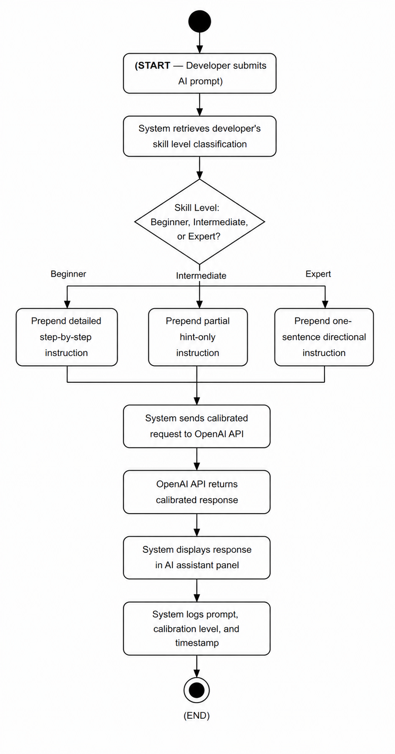

3.8. Use Case 8 — Track Skill Development

ID | UC008
Name | Track Skill Development
Description | This use case describes how the system computes and displays longitudinal skill development trends for a developer, making growth in overall development efficiency visible over time.
Requirement(s) | FR009
Actor(s) | Developer, Team Lead
Precondition | The developer is logged in and has at least 3 completed and analysed sessions.
Postcondition | The Skill Development panel on the dashboard displays trend lines and a Skill Growth Index.
Basic Flow | Basic Flow  1. Developer opens the Skill Development panel from the dashboard navigation.  2. System retrieves all historical session metrics from MySQL for the developer's account.  3. System computes trend values: coding speed improvement, error reduction, AI dependency reduction, and code quality improvement.  4. System renders four trend line charts and an overall Skill Growth Index card.  5. Developer reviews trends and identifies areas of improvement and areas needing focus.  Alternative Flow  1. Team Lead selects a developer and views that developer's skill development trends.  Exceptions  1. Fewer than 3 sessions — System displays: Complete at least 3 sessions to unlock your Skill Development report.

Diagrams
The activity diagram below describes the flow of events for Skill Development Tracking (UC008).

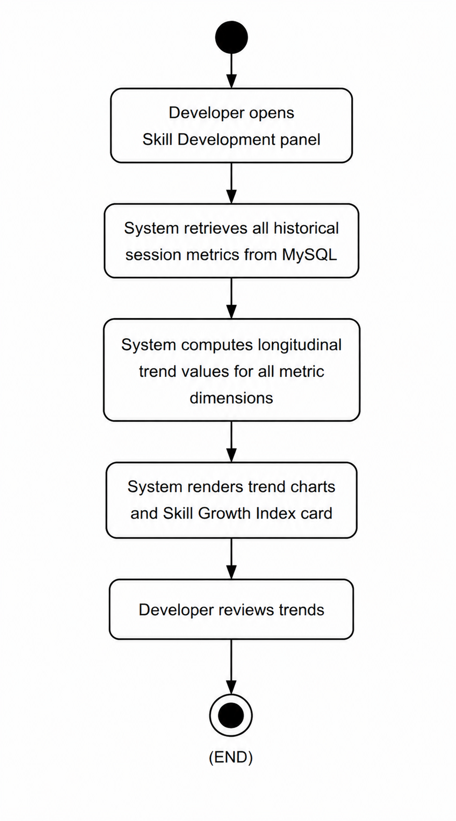

3.9. Use Case 9 — Manage System Administration Panel

ID | UC009
Name | Manage System Administration Panel
Description | This use case describes the System Administrator's ability to manage user accounts, create and assign coding tasks, and monitor overall platform activity through a dedicated administration panel.
Requirement(s) | FR010
Actor(s) | System Administrator
Precondition | The System Administrator is authenticated and has accessed the Administration Panel.
Postcondition | The requested administrative action is completed and reflected immediately in the system.
Basic Flow | Basic Flow — User Management  1. Administrator opens the Users section.  2. Administrator filters by role or status (Active or Inactive).  3. Administrator selects a user and edits role, resets password, or deactivates the account.  4. System applies the change and logs the administrative action.  Basic Flow — Task Management  1. Administrator opens the Tasks section.  2. Administrator creates a new task or edits an existing one.  3. Administrator assigns the task to selected developers and clicks Save.  4. System saves the task and notifies assigned developers.  Basic Flow — Platform Report  1. Administrator clicks Generate Platform Report.  2. System computes total sessions, average Efficiency Score, and AI Dependency distribution.  3. System displays the report and offers a downloadable PDF.  Exceptions  1. Administrator attempts to delete a user with active sessions — System prevents deletion and requires deactivation first.

Diagrams
The activity diagram below describes the flow of events for system administration (UC009).

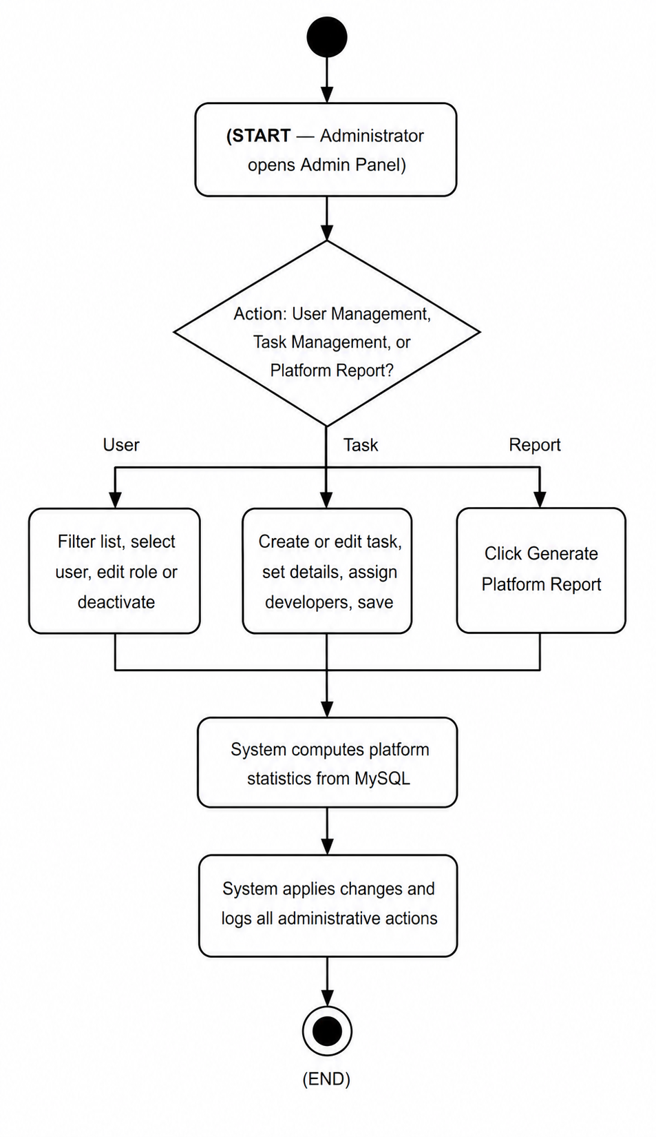

4. References
[1] P. Vaithilingam, T. Zhang, and E. L. Glassman, "Expectation vs. Experience: Evaluating the Usability of Code Generation Tools Powered by Large Language Models," in Extended Abstracts of the 2022 CHI Conference on Human Factors in Computing Systems, ACM, 2022.

[2] A. Ziegler et al., "Measuring GitHub Copilot's Impact on Productivity," Communications of the ACM, vol. 67, no. 3, pp. 54-63, 2024.

[3] GitHub, Inc., "GitHub Copilot — Your AI pair programmer," [Online]. Available: https://github.com/features/copilot

[4] OpenAI, "OpenAI API Documentation," 2024. [Online]. Available: https://platform.openai.com/docs

[5] Laravel LLC, "Laravel — The PHP Framework for Web Artisans," 2024. [Online]. Available: https://laravel.com

[6] Meta Open Source, "React — A JavaScript library for building user interfaces," 2024. [Online]. Available: https://react.dev

[7] Microsoft Corporation, "Monaco Editor," GitHub Repository, 2023. [Online]. Available: https://github.com/microsoft/monaco-editor

[8] M. A. Siddiqui and R. Ahmed, "Measuring Developer Productivity in AI-Augmented Environments," IEEE Transactions on Software Engineering, vol. 49, no. 4, pp. 1823-1840, 2023.

[9] Oracle Corporation, "MySQL 8.0 Reference Manual," 2024. [Online]. Available: https://dev.mysql.com/doc

